Game Design Document

Fill up the Following document

1. Write the title of your project.

THE SURVIVAL OF EARTH

1. What is the goal of the game?

Goal:

Winning:

You win if:

The player has to touch the things that the earth needs and dodge the obstacles by jumping and save the earth and meanwhile also collect energy drinks to increase the score to win

Losing:

You lose if:

The player touches the obstacle four times which will increase the death percent and decrease the safe percent

1. Write a brief story of your game?

Story:

Sonic has to save the earth from the clutches of death by global warming. You have to help sonic for carrying the earth on his head and save it from carbon dioxide bomb, woodcutter, industries and cars that produce gases and meanwhile also collect the seeds and water and so on for earth. In return the earth will give you energy drink and food to eat all the best to save the earth!

1. Which are the playing characters of this game?

* Playing characters are the ones which respond to the user based on the input from the user
* Cars, monkeys, dinos, wizards etc, are the playing characters in the game.

|  |  |  |
| --- | --- | --- |
| Number | Character Name | What can this character do? |
| 1 | Sonic | The character can jump  He can move with arrow keys left or right |
| 2 |  |  |
| 3 |  |  |
| 4 |  |  |
| 5 |  |  |
| 6 |  |  |
| 7 |  |  |
| 8 |  |  |

1. Which are the Non Playing Characters of this game?

* Non Playing characters are the ones which don't have an action or behaviour when the user interacts with the game.
* Hurdles, stones, bananas, coins, etc are non playing characters in the game.

|  |  |  |
| --- | --- | --- |
| Number | Character Name | What can this character do? |
| 1 | Industry that releases smoke |  |
| 2 | Carbon dioxide bomb |  |
| 3 | Car releasing smoke |  |
| 4 | Woodcutter |  |
| 5 | axe |  |
| 6 |  |  |
| 7 |  |  |
| 8 |  |  |

Draw your imagination of this game. What does this game look like?

* Draw the game either on your computer or on paper,
* Add images of scenes of the game to show each of the playing and non-playing characters at least once.

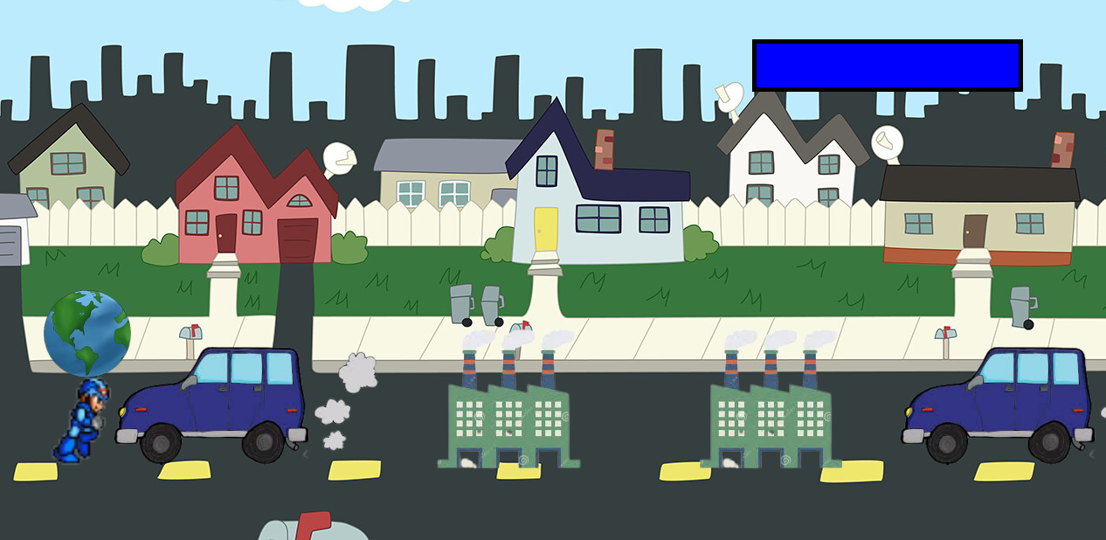

How do you plan to make your game engaging?

I PLAN TO MAKE MY GAME ENGAGING BY INCREASING THE SPEED TIME TO TIME AND BY GIVING THE PLAYER CHANCE TO WIN. I ALSO PLAN TO MAKE IT ENGAGING BY GIVING THE BEST ANIMATION THAT EVERYONE LIKES.